CORONAVIRUS (COVID-19) AND THE WORKPLACE

Guidance for contacts of people with confirmed coronavirus (COVID-19) infection who do not live with the person (18 December 2020)
www.gov.uk/government/publications/guidance-for-contacts-of-people-with-possible-or-confirmed-coronavirus-covid-19-infection-who-do-not-live-with-the-person

Contact means you:
- had a face-to-face conversation within one metre
- were within one metre for one minute or longer
- were within 2 metres for more than 15 minutes (over one day)
- travelled in the same vehicle

Then you:
- must stay at home for isolation – Includes the date of your last contact and the next 10 full days
CONTACT = DAY 0 | DAY 1 | 2 | 3 | 4 | 5 | 6 | 7 | 8 | 9 | 10 | 11
ISOLATE |  |  |  |  |  |  |  |  |  |  | FREE

COVID-19: management of staff and exposed patients or residents in health and social care settings (17 December 2020)
www.gov.uk/government/publications/covid-19-management-of-exposed-healthcare-workers-and-patients-in-hospital-settings/covid-19-management-of-exposed-healthcare-workers-and-patients-in-hospital-settings

If you were
- providing patient care, and
- you were wearing correct PPE, then you:
- will not be considered as a contact
- will not be required to self isolate

Please note, if you were
- not providing patient care (for example, having lunch), or
- not wearing correct PPE, then you:
- will be considered as a contact
- will be required to self isolate

If you develop symptoms, you should take a PCR test.

Standard operating procedure (SOP) for general practice in the context of coronavirus (COVID-19) (24 December 2020)
www.england.nhs.uk/coronavirus/publication/managing-coronavirus-covid-19-in-general-practice-sop/

If you are patient-facing primary care staff, you should:
- test yourself twice weekly (lateral flow test)
- report your result to Public Health, via the NHS Digital online platform

How to take a Lateral Flow test
Please watch the video
www.youtube.com/watch?v=kZhSPnnXyPo
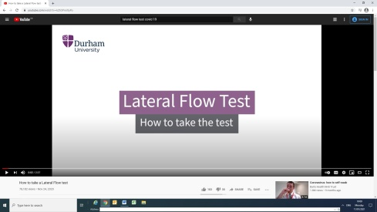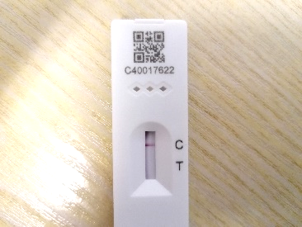

You can do the test on yourself, and read the result in 30 minutes.

Reporting the test result
Please use the NHS Digital online platform
www.gov.uk/report-covid19-result
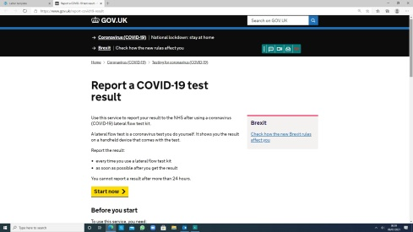

For reference:
Ability of Lateral Flow tests to detect the virus
- in over 95% of cases with high concentration of virus
- in 76.8% of cases overall
- in 58.9% of cases when the user technique is not good
www.gov.uk/government/publications/evidence-on-the-accuracy-of-lateral-flow-device-testing

RETURN TO WORK
